CSCD327 – Lab6

1)

update instructor

set salary = salary * 1.1

where dept_name = 'Comp. Sci.';

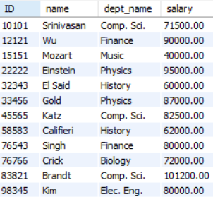

2)

delete from course

where course_id not in

(select course_id from section);

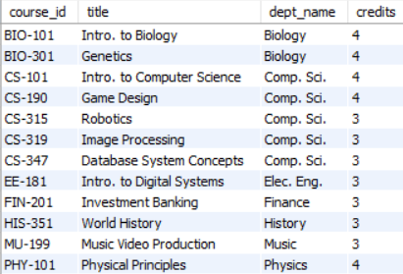

3)

create temporary table temp_instructor

select *

from instructor;

insert into temp_instructor

select id, name, dept_name, 10000

from student

where tot_cred > 100;

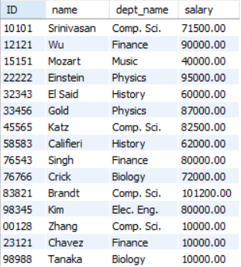

4)

create temporary table temp_course

select * from course;

create temporary table temp_section

select * from section;

create temporary table temp_takes

select * from takes;

insert into temp_course

values ('CS-001', 'Computer Basics', 'Comp. Sci.', 2);

insert into temp_section

values ('CS-001', 1, 'Winter', 2018, ' ', ' ', ' ');

insert into temp_takes

select ID, 'CS-001', 1, 'Winter', 2018, null

from student

where student.dept_name = 'Comp. Sci.';

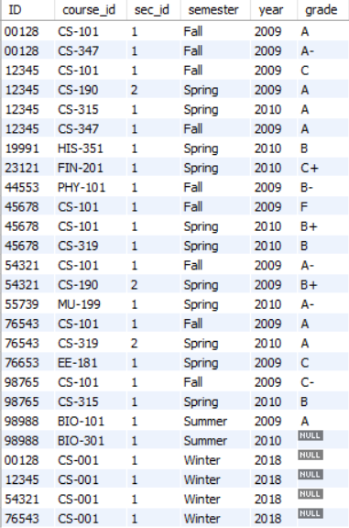

5)

create temporary table temp_takes1

select * from temp_takes;

delete from temp_takes1

where course_id = 'CS-001' and

sec_id = 1 and

semester = 'Winter' and

year = 2018 and

ID = (select ID

from student

where name = 'Zhang');

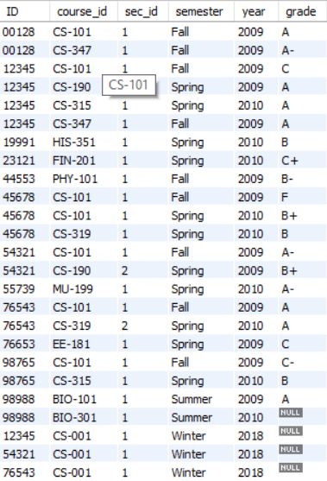

6)

delete from temp_takes1

where course_id = (select course_id

from course

where lower(title) like '%database%');

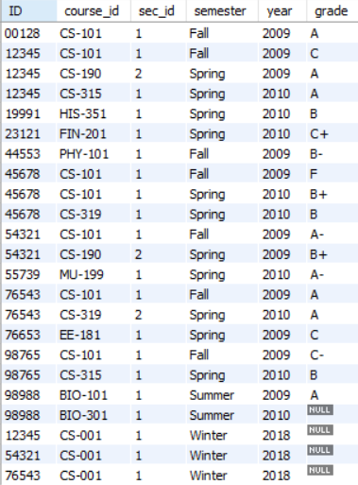

7)

create temporary table temp_student

select * from student;

update temp_student

set tot_cred = (select sum(temp_course.credits)

from temp_takes1 join temp_course using(course_id)

where temp_takes1.ID = temp_student.ID and

(temp_takes1.grade != 'f' or temp_takes1.grade is not null));

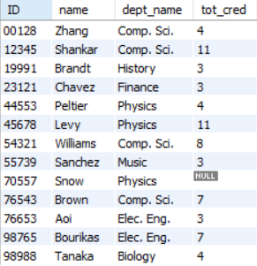

8)

create table STORE_REPS(

Rep_ID int(5),

Last varchar(15),

First varchar(10),

Comm char(1) default 'Y',

constraint Rep_ID primary key(Rep_ID) );

9)

alter table STORE_REPS

modify Last varchar(15) not null,

modify First varchar(10) not null;

10)

create table BOOK_STORES(

Store_ID int(8) not null,

Name varchar(30) unique not null,

Contact varchar(20),

Rep_ID int(5),

primary key(Store_ID) );

11)

alter table BOOK_STORES

modify Rep_ID int(5),

add constraint book_stores_Rep_ID_fk

foreign key(Rep_ID) references STORE_REPS(Rep_ID) on delete cascade;

12)

create table REP_CONTRACTS(

Store_ID int(8) not null,

Name int(5),

Quarter char(3) not null,

Rep_ID int(5) not null,

constraint rep_contracts_pk primary key(Store_ID, Rep_ID, Quarter),

constraint rep_contracts_store_id_fk foreign key(Store_ID)

references BOOK_STORES(Store_ID),

constraint rep_contracts_rep_id_fk foreign key(Rep_id)

references STORE_REPS(Rep_ID));